**How to install PHP using command prompt**

1. Download the latest version of PHP from <https://windows.php.net/download/>
2. After downloading the latest version. Extract the file
3. Rename the php.ini-development to php.ini
4. Go to your environment variables and set the path under your system variables “PATH”
5. Check the the version of you PHP on cmd

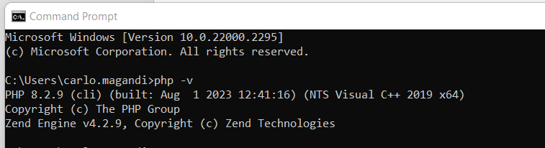

1. Navigate to your project folder path and open the github or command prompt and run “php -S localhost:8080”